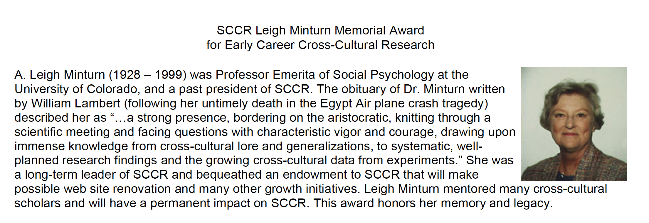

Eligibility
- Has not been awarded tenure at any university, and
- Not more than 5 years since date of receipt of terminal degree (at tie of nomination)

Criteria
- Outstanding culture-related scholarly productivity
- Outstanding culture-related scholarly potential
- Active contributor to SCCR
- Past attendee of at least 2 SCCR conferences

Award
- $300 prize
- Certificate of award

Nominations Process
- Self-nominations, nominations by Award Committee members or by dues-paying SCCR members
- Send nominations to Ted Bartholomew, Ph.D.: tbarthol@scrippscollege.edu
- Application letter, CV, and supporting letters/materials all sent electronically to above address
- Nominations and application materials due by January 12, 2026
- Award must be received in person at conference

