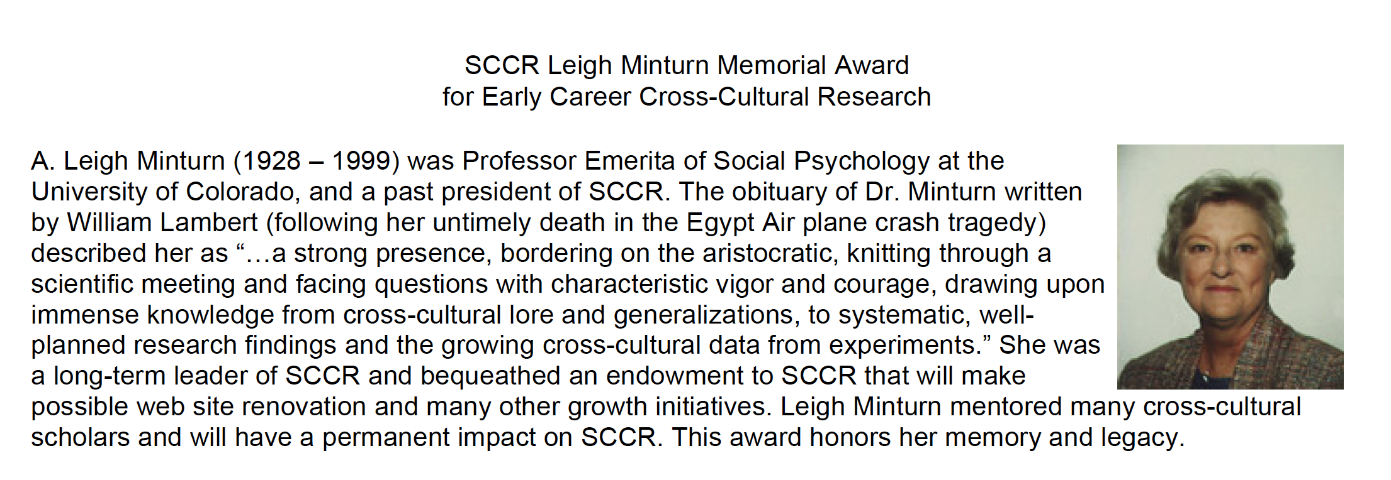

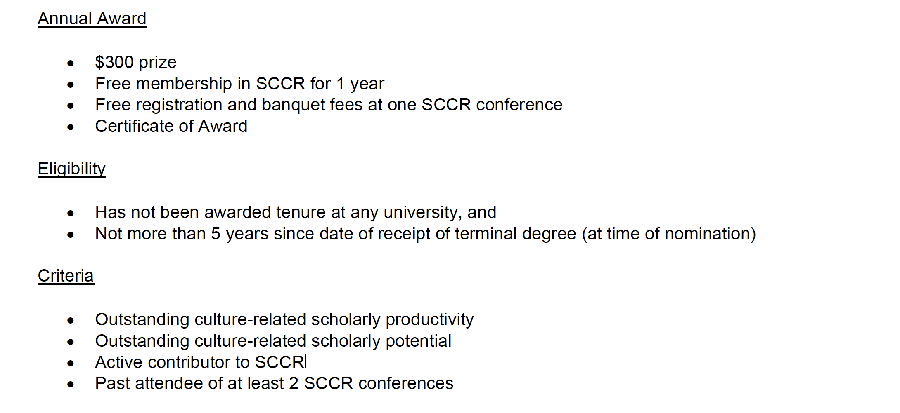
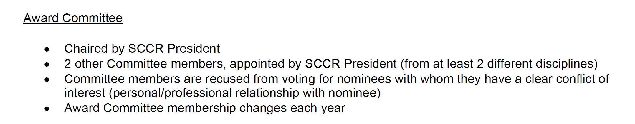

Nominations Process
- Self-nominations, nominations by Award Committee members or by dues-paying SCCR members
- Application letter, CV, and supporting letters/materials all sent electronically to SCCR President
- Nominations and application materials due by November 20, 2018
- Award announced by December 20
- Award must be received in person at conference

